**Research Question Hierarchy**

**[Slide #1]**



Hello and Welcome to this session on The Practitioner-Researcher Question Hierarchy, where we will explore how this framework aligns with and supports scholar-practitioner research.

**[Slide #2]**

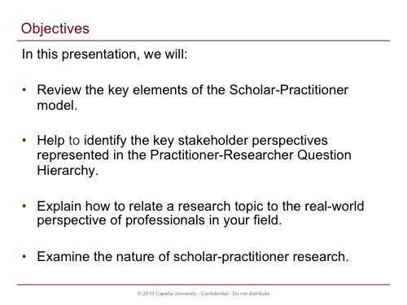

The purpose of this session is to introduce you to a hierarchy for organizing questions in the Research Questions section of a dissertation proposal that builds a connection between this hierarchy and scholar-practitioner inquiry. In accomplishing this, we'll review key elements of the scholar-practitioner model, identify key stakeholder perspectives that are necessary to consider when doing scholar-practitioner research, highlight the need to relate research to real-world situations, and explore the nature of questions at each level of the question hierarchy.

**[Slide #3]**

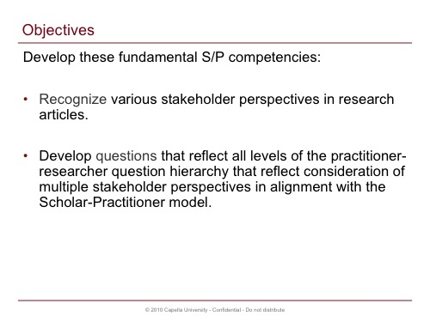

Note, that a fundamental competency to be developed as a scholar-practitioner is the ability to uncover, recognize, understand, and appreciate multiple perspectives of the people who have a stake in research conducted within your field. You may eventually be expected to explicitly connect with various stakeholder perspectives when developing your dissertation research and proposal. Prior to this, however, you can begin to develop this competency through the careful review of research articles you dissect and critique as you read in the literature on topics of interest to you through your coursework.

So, whether you're working on developing your own research questions, or continuing to learn how to critically review research articles, keep in mind that you need to be considering the larger context in which the phenomenon being studied exists. Ideally then, you can begin to develop a "systems" perspective to your exploration and learning about the topics you're studying.

**[Slide #4]**

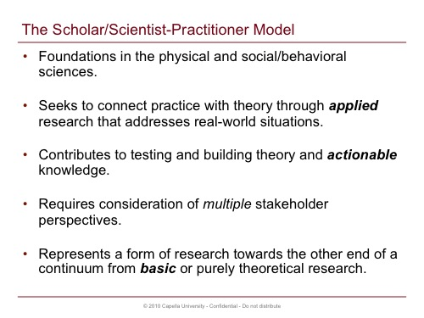

The scholar- or scientist-practitioner model emerged almost simultaneously in both the physical and social sciences, as the perceived need to train future generations of researchers led to a call for more intensive course and field work focused on research methods in doctoral education. The intent was to provide more hands-on training in research, including more research assistantships and project-based learning in courses, which highlighted the need for researchers trained in university settings to seek to connect practice with theory through more applied research that addresses real-world situations and problems.

Thus, scholar-practitioner research done within this tradition was seen as always having the potential to build and test theory, but of at least equal importance was the goal of creating actionable knowledge that practitioners could apply in their work towards improving their professional effectiveness.

Engaging in this kind of research involves consideration of multiple stakeholder perspectives, that includes not only the practitioner, but also the people and communities to which the practitioner is accountable or with whom they are interdependent, such as employees, customers, suppliers, regulatory bodies, boards, tax payers, or the community which they serve. The researcher also has a stake in scholar-practitioner research, as we are the ones who strive to connect practice with theory, who serve as advocates for "evidence-based practice," and as such are the ones most directly responsible for bridging the theory-research-practice gap!

Some of the research conducted in university settings has always been challenged as being too theoretical in nature, or "academic," and claims that "Ivory Tower" research was either out-of-touch with the real world, or didn't do enough to help society deal with pressing questions has provided fuel to those who advocate for more "applied" forms of research in contrast to "basic" theoretical research. Scholar-practitioner research lies more towards the end of a continuum or spectrum of types of research in that it has both a theoretical and practical focus.

**[Slide #5]**

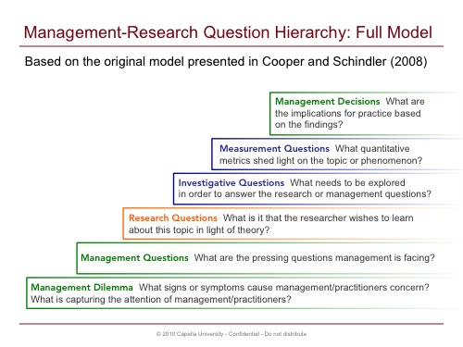

The question hierarchy we're promoting is based on the model presented in a 2008 business research methods text by Cooper and Schindler that originally included six levels oriented to the work of managers and leaders as decision-makers. The top of this hierarchy highlights what the business researcher should keep in mind, where the data they collect will serve to inform management decisions. This reflects a commitment to evidence-based practice that we believe is a hallmark of scholar-practitioner inquiry.

At the bottom of the original hierarchy is the management dilemma along with management questions which drive a research or inquiry project. This part of the hierarchy highlights that the scholar-practitioner is grounded in real-world situations that practitioners face: The pressing problems, strategic threats or opportunities, unexplored creative innovations, and possibilities for addressing real-world situations and improving professional practice.

At the center of the original hierarchy lies the researcher's perspective that connects with theory, and the perspective of participants or other data sources that will be used to answer the management and research questions.

For the sake of simplifying this hierarchy as a tool in developing cross-disciplinary research proposals, we've pared this down to three levels that best capture three different stakeholder perspectives: The practitioner, the researcher, and study participants. Employing this hierarchy as a tool helps learners to create proposals that reflect a commitment to the scholar-practitioner model across the various schools at Capella.

**[Slide #6]**

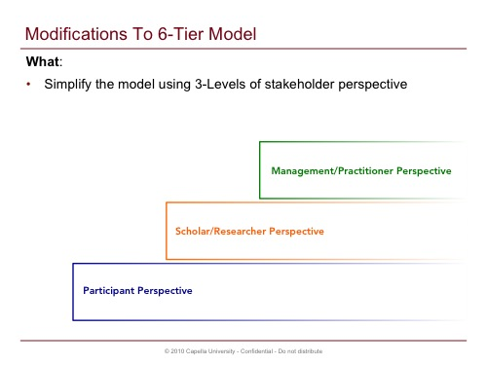

What we've done, is to collapse some of the levels within Cooper and Schindler's original hierarchy that included six levels, down to three levels: management/practitioner, scholar/researcher, and participants.

**[Slide #7]**

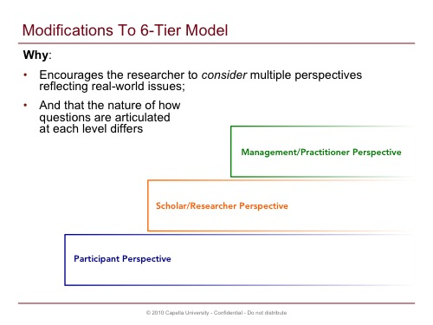

The rationale behind this is that the three levels still encourage the researcher to consider multiple stakeholder perspectives that are key to addressing real-world situations. And by highlighting these three perspectives, we see that the nature of questions at each level differs.

Recognizing, understanding, and appreciating multiple perspectives reflects the kinds of "systems thinking" that PhD scholar-practitioners are expected to possess. These perspectives might not only represent different stakeholder views, but also different cultural dynamics or philosophic worldviews.

**[Slide #8]**

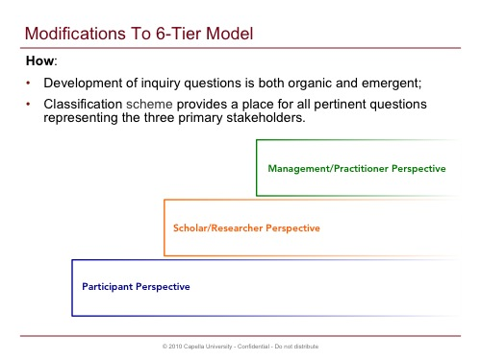

When developing inquiry questions, the three levels serve as repositories for the most common questions that you'll generate: Questions asked by management or other practitioners, questions that you as the scholar pose that reflect a connection to theory and past research, and questions that will ultimately be presented to study participants.

The process of generating and working with questions is very organic and emergent, and by understanding that the types of questions you develop will take on different forms and reflect different perspectives, it's helpful to know that there's framework into which your questions can reside.

**[Slide #9]**

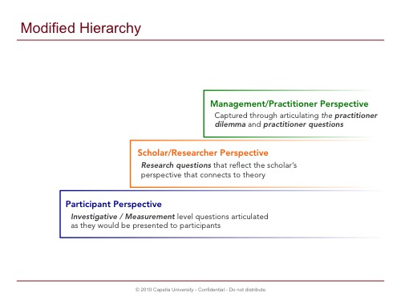

The modified hierarchy is organized with the management/practitioner perspective at the top, which is captured by articulating ideally both the practitioner dilemma and the practitioner questions.

To readers of a proposal, this logically comes first when the expectation is that research done in the tradition of scholar-practitioner inquiry must have a connection to real-world, practical settings.

The scholar-practitioner or researcher perspective lies at the middle of the modified hierarchy. This includes the study's main research questions that should be written in such a way that reflect the scholarly connection to the body of knowledge found in the literature.

At the bottom of the hierarchy, is the participant perspective, which includes questions that are written in a form that will be presented to participants, such as survey or interview questions.

Note, that it's possible that practitioners ARE the participants in the study, though this isn't always the case. Nonetheless, even if this is the case, the phrasing of questions differs from the practitioner and participant levels.

Let's look at each of these levels separately, to learn more about how the type and form of questions at each level differ.

**[Slide #10]**

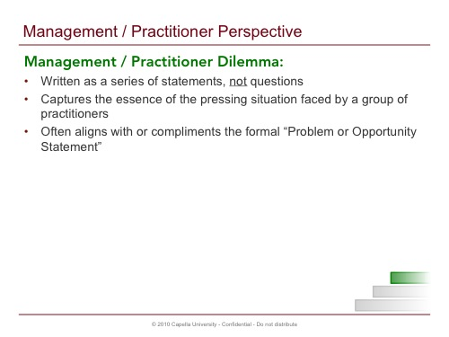

The management practitioner perspective is best reflected by two components: the practitioner dilemma and the practitioner questions.

The practitioner dilemma is a statement, that is NOT written as a question. The statement captures the essence of the pressing situation practitioners face, and written as the practitioner would articulate it. Often, there is alignment between the dilemma captured here, and the "Statement of the Problem" presented in Chapter 1 of a dissertation proposal. This alignment is yet another part of the internal consistency of the focusing elements of a proposal that also includes the purpose statement, research questions, and the study's proposed methodology.

**[Slide #11]**

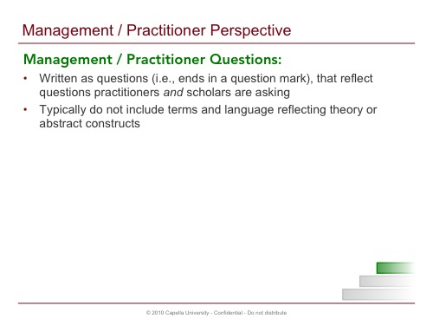

Similarly, the practitioner questions are written using the language and vernacular of practitioners, and relate directly to the dilemma. The scholar-practitioner may also have a direct tie to these questions given their interest in a field of inquiry about a topic that they're expert in (or becoming expert).

Let's look at some examples.

**[Slide #12 – Practitioner Example #1]**

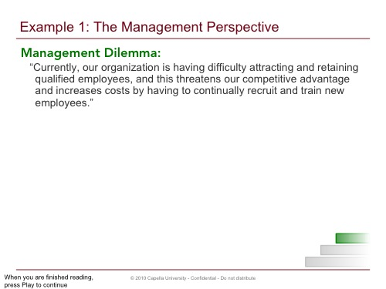

Here's an example of a practitioner dilemma from the management or organizational perspective:

Note, that this is written as a complex sentence that ends in a period: It isn't written as a question. One should be able to see the presence of the practitioner in the statement, for instance as this shows up here in talking about "our organization," which could easily reflect the situation facing an employer, manager, or Human Resources professional.

**[Slide #13 – Practitioner Example #1]**

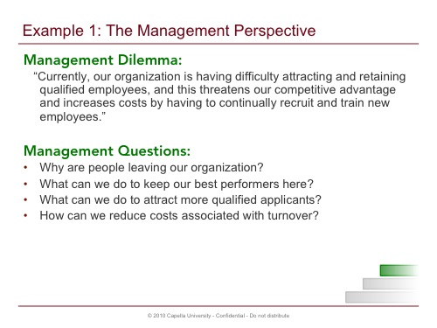

Reasonable and logical questions that management might articulate--and that you as the scholar-practitioner bring to light--connect to the dilemma that seeks to uncover what is taking place, what might be some root causes, and that seek to address the situation, such as:

* Why are people leaving our organization?
* What can we do to keep our best performers here?
* What can we do to attract more qualified applicants?
* How can we reduce costs associated with turnover?

Note, that the same person/perspective should be evident in these questions as was present in the management dilemma. The "we" in these questions can imply multiple stakeholders, for instance those doing the recruiting, selection, and hiring, those supervising employees, etc.

**[Slide #14 – Practitioner Example #2 – Education Perspective]**

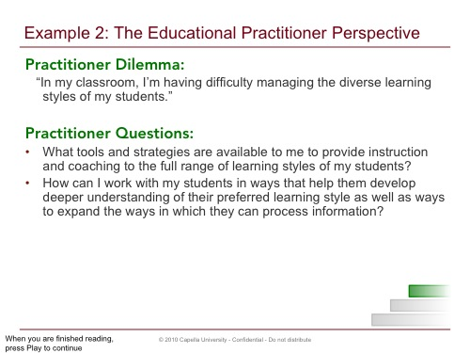

Here's another example of a practitioner perspective from a teacher's viewpoint.

Note again, that the dilemma is written as a statement, and the questions as sentences ending in a question mark. Note also, that these are written as they might be voiced by the teacher directly.

When you are reading research articles, the extent to which the author presents some practitioner perspective can vary widely. Some authors may be very mindful of connecting with various stakeholders and the "real-world" dilemma or practical problem, while other authors remain in the upper reaches of the "ivory tower" failing to make an explicit connection to some real-world problem.

Remember, while we here at Capella seek to embrace the scholar-practitioner model that connects research with theory and practice, what you read in the literature can reflect research along the entire continuum from more theoretical and basic to more practical and applied types of research.

**[Slide #15]**

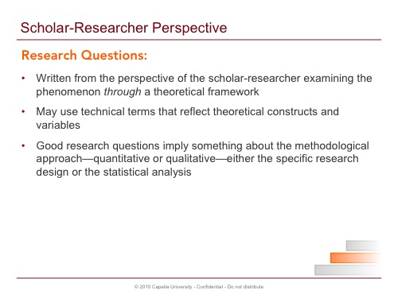

Let's look at the next level within the 3-tiered hierarchy: The researcher's perspective.

Research questions represent a different level and view of reality, as ontologically the scholar-practitioner is bringing to bear advanced training in research methods AND is rooted in the knowledge base represented by the scholarly literature. This includes theory and previous research on the topic.

Because researchers look at data through a theoretical framework, the key constructs and variables that make up theory and the more sophisticated or technical terms associated with these constructs necessarily show up in questions articulated from the scholar-practitioner's or researcher's perspective.

Good research questions should imply something about the methodological approach, perhaps the specific research design, and even the statistical analysis to be used for testing a hypothesis associated with a quantitative research question.

**[Slide #16 – Research Question Example #1]**

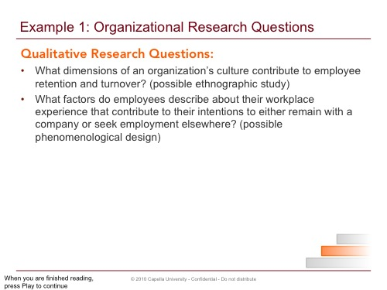

Here are some research questions that align with the organizational situation presented earlier related to employee turnover.

With respect to the qualitative questions, note that these questions imply something about the nature of the study. For instance, use of the term culture suggests that the study would likely use an ethnographic design. In the second question, the term describe is often associated with use of interviews where participants can relate a rich story and narrative about their experience. The word experience in combination with describe, also implies a phenomenological design.

**[Slide #17 – Research Question Example #1]**

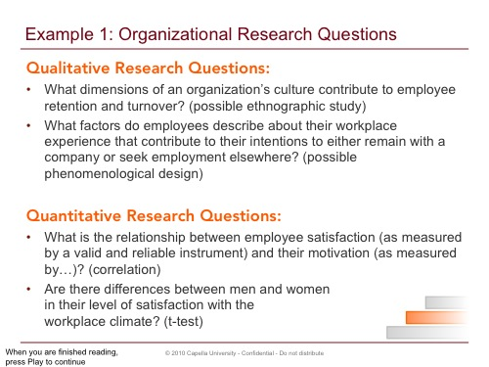

Here are two quantitative questions grounded in the dilemma faced by management:

Here again, each question implies something about the methodology, and also reflects the theoretical constructs that are being operationally defined: satisfaction and motivation. In the first question, the term relationship suggests use of a correlational analysis. If we were going to be running a Chi-square, the term association would be more appropriate. In the second question, the word difference implies a t-test or some other difference test. Here again also, we see the variables: gender, and satisfaction with workplace climate.

Note also, that quote, as measured by, unquote, is always IN the question, as it MUST be in your MIND. This is because in quantitative research these variables must be measured using valid and reliable instruments. As you read research questions, you can always be inserting this clause in your mind, if not in actuality.

**[Slide #18 – Researcher Example #2]**

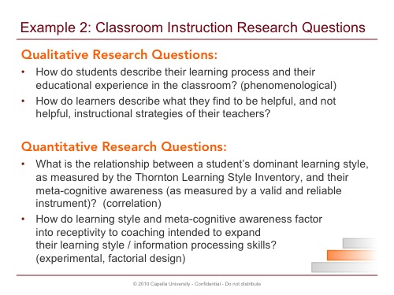

Connecting again with the challenges faced by teachers in managing the diverse learning styles in their classroom, here are some research questions that align with this situation.

Though these questions are somewhat simplified for use here as examples, and therefore may not represent realistic research questions on this particular phenomenon, here again you can see that there is alignment between these questions, and the practitioner dilemma and questions presented by the teacher previously. Also, an attempt has been made here to craft these questions in a manner that suggests something about the methodological approach, specific research design, or the type of data analysis to be used..

As you read research articles on your topic, pay attention not just to the deeper meaning of the research questions, or hypotheses, stated by the authors, but also the manner in which the questions are written in terms of what they imply about the study's design and methods. This involves analysis, synthesis, and evaluation at the highest levels of Bloom's taxonomy!

**[Slide #19]**

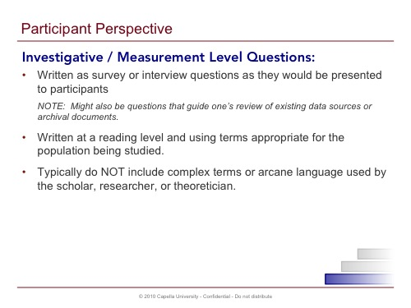

Questions at the investigative/measurement level reflect a third perspective that differs from that of the manager/practitioner and the scholar/researcher. And while these questions are written in a very different style, the connections back to the management dilemma through the research and management questions, should be evident. These connections relate to the internal consistency and alignment in these focusing elements, back to and including the study's problem and purpose statements.

These questions are written in the form they will be presented to participants, either as survey items or interview questions. They are written at a reading level appropriate for the population, and using terms with which participants are familiar. Where we saw use of the technical terms for constructs and variables in the research questions, these terms most often do not show up in questions at this level.

**[Slide #20 – Investigative / Measurement Question Example #1]**

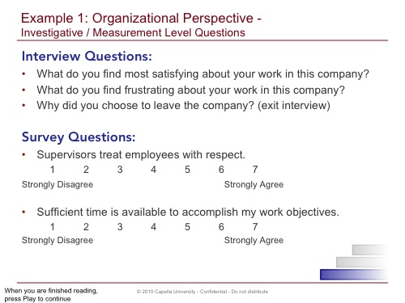

Here are some examples relating back to the employee turnover situation. Imagine these questions being presented to someone in a face-to-face or telephone interview.

Note, these are obviously just a few questions that you might pose in an interview with someone exploring this complex phenomenon. And this is what we hope to see in your proposals: A small sample of questions that reflect this level of stakeholder perspective. You'll present the complete interview protocol or survey in the appendix of a proposal. Here, we simply want to see that you can and have captured this level of perspective within the hierarchy to round out and fulfill each level of the modified hierarchy.

As you can see, the quantitative measurement-level questions here are written as Likert-type survey items.

Being able to envision, early on in the proposal / research design process, and articulate questions at this level is not only necessary, but a helpful and even natural part of what should emerge when you allow yourself to brainstorm and generate questions: ANY and ALL questions -- on your topic.

This level represents the repository for all the questions you generate that you'd direct towards participants.

**[Slide #21 – Investigative / Measurement Questions Example #2]**

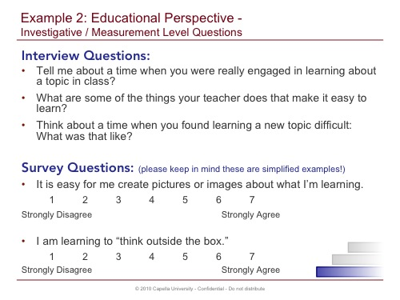

Connecting again with the classroom example, you can see that these questions are written as they might be presented to the students themselves as participants in the study.

Please remember that the presentation of questions at this level in the body of your proposal in Chapter 1, if this is encouraged by your school, typically involves only a small sample of questions that serve as an example of survey or interview questions, and that the actual survey or interview protocol is to be provided as an appendix to the proposal.

When you are reading and dissecting research articles, the author might not include the actual survey instrument or interview protocol, so this level might not be present in the article.

**[Slide #22]**

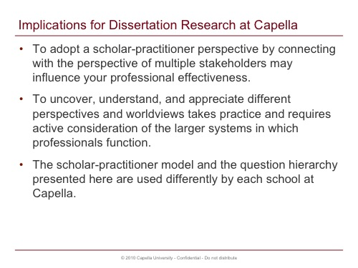

What are the implications from using the practitioner-researcher question hierarchy in dissertation research here at Capella?

As advocates for "evidence-based practice," your ability to adopt a scholar-practitioner perspective by connecting with the worldview of multiple stakeholders may influence your professional effectiveness.

The ability to uncover, understand, and appreciate different perspectives and worldviews takes practice, and most likely requires that you actively consider the larger systems in which professionals function. One way to develop this competency is to consciously consider the various stakeholders of the studies you read in research articles. Who were the participants? To whom are participants accountable? Who supervises them? What's the larger system in which these participants, and the phenomenon being examined, resides? How the scholar-practitioner model and the question hierarchy presented in this session is used here at Capella, differs across each school.

Consequently, the particular form or style of research questions one chooses to put forth can take on many different and varied forms. For the beginning researcher, keeping things simple is often a great place to start!

**[Slide #23 & 24]**

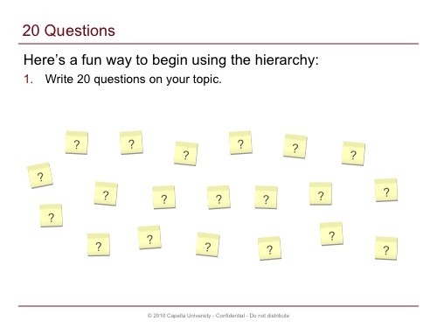

Here's a fun way to begin using the hierarchy:

1. First, write 20 questions on your topic. Post-it notes work well if you'd like to do this as an affinity diagram exercise. Write one question per Post-it note.

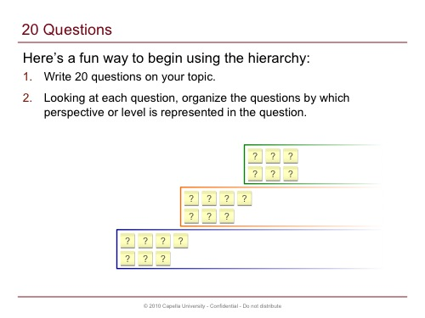

2. Then, looking at each question, organize the questions by which perspective or level the question represents. For example, questions that are phrased to be asked towards a participant would be investigative / measurement level questions. Those that reflect questions management is asking are management level questions. Those that lie somewhere in between…might be…research questions?

3. Be sure that you're asking questions about what, who, when, where…and the higher-level questions about how and why!

**[Slide #25]**

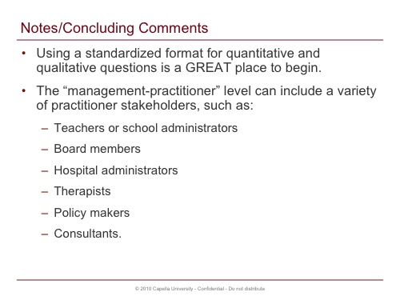

Here are some things to keep in mind with respect to the information presented in these slides, the hierarchy, how to apply this as you critically review and analyze research articles, or as you generate questions on a prospective topic of inquiry for your dissertation:

First, please know that the examples provided here are meant to be relatively simple and straightforward. Working with research questions using the more standardized format for each type of question—quantitative and qualitative—is a GREAT place to begin. With practice, feel free to develop more complex research questions.

We have attempted to present the question hierarchy in a way that can be used across disciplines to support a scholar-practitioner orientation.

When we refer to the management-practitioner level, this could include a variety of practitioner stakeholders, such as teachers or school administrators, board members, hospital administrators, therapists, policy makers, or consultants.

**[Slide #26]**

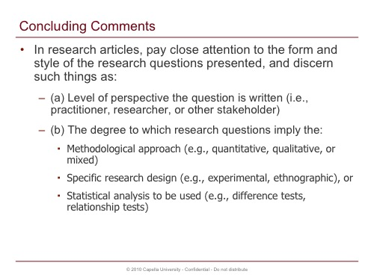

As you read research articles, pay close attention to the form and style of the research questions the authors present, and see if you can discern such things as (a) the level of perspective the question is written at (in other words—practitioner, researcher, or other stakeholder); pay attention also to (b) the degree to which research questions imply the methodological approach (for example—quantitative, qualitative, or mixed), specific research design (for example—experimental and ethnographic) or the statistical analysis to be used (for example—difference tests and relationship tests)

**[Slide #27]**

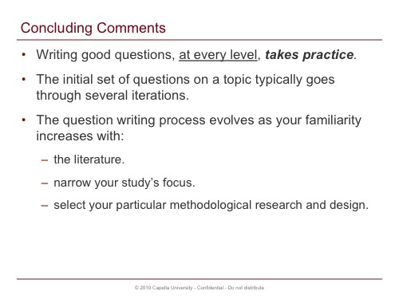

Keep in mind, that learning to write good questions, at every level, takes practice, and the initial set of questions one generates on a topic typically goes through several iterations involving revision, editing, and word-smithing.

This is part of the organic and emergent process of developing good research, interview, or survey questions. This process evolves as you gain more familiarity with the literature, narrow the focus of your study, and decide on the particular methodological approach and research design.

**[Slide #28]**

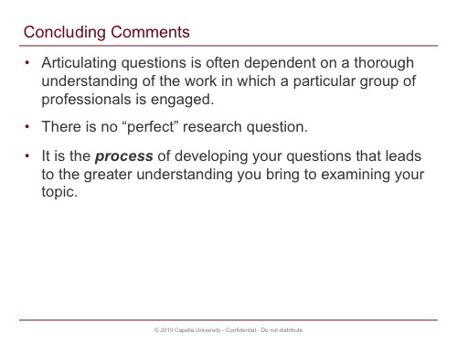

Also, your ability to articulate questions reflecting the management or practitioner perspective is often dependent on how well you understand the nature of work in which a particular group of professionals is engaged.

While greater precision in focus and language is to be sought, keep in mind that there really is no one perfect research question. It's the process of working with your questions as you read in the literature that leads to greater understanding about the phenomenon, and what it is you want to explore and learn about it through a formal inquiry project based on the theoretical framework you bring to examining the topic.

**[Slide #29]**

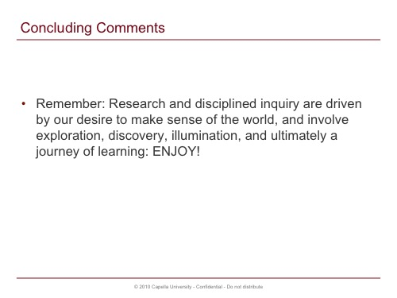

Remember, research and disciplined inquiry is driven by our desire to make sense of the world, and involves exploration, discovery, illumination, and ultimately a journey of learning. ENJOY!

Thank you for taking the time to listen to this session. This PowerPoint represents what we believe is a great resource for you to refer back to throughout your doctoral journey, and reflects our university's commitment to the scholar-practitioner tradition!

**[Slide #30]**

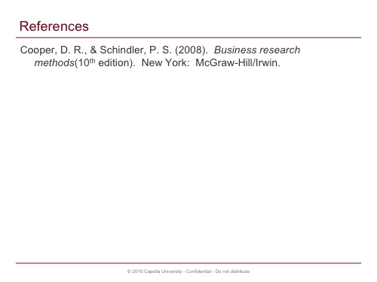

**References**

* Cooper, D. R., & Schindler, P. S. (2008). Business research methods (10th ed.). New York: McGraw-Hill/Irwin.

**Credits**

Subject Matter Expert:

Dr. Richard Flor

Interactive Design:

Justin Lee, Brent Berheim, Jay Austin

Instructional Designer:

Julie Primoli

Project Manager:

Andy Johnson

Licensed under a [Creative Commons Attribution 3.0 License](http://creativecommons.org/licenses/by-nc-nd/3.0/).